Unemployment rate
1976 – 2009 monthly by state
Source: http://www.bls.gov/lau/#data

Median house price
2008 – 2009 monthly by region (US, NE, MW, S, W)
Sales price of existing homes. Includes all existing-home sales — single-family, condos and co-ops, rolled into monthly and annual totals
Also has breakout by home type, monthly, by region
Source: http://www.realtor.org/research/research/ehsdata

Existing Single-Family Home Prices: 1968-Present, annual by region (US, NE, MW, S, W): Table 8B
Source: http://www.huduser.org/periodicals/USHMC/fall98/histdat2.html#tbl4_08b based on National Association of Realtors

Median income
1975 – 2007 annual by region (US, NE, MW, S, W)
Source: http://www.census.gov/hhes/www/income/histinc/h06AR.html

Household Debt and Financial Obligations Ratio
1980 – 2008 quarterly on national level:
The household debt service ratio (DSR) is an estimate of the ratio of debt payments to disposable personal income. Debt payments consist of the estimated required payments on outstanding mortgage and consumer debt.
The financial obligations ratio (FOR) adds automobile lease payments, rental payments on tenant-occupied property, homeowners' insurance, and property tax payments to the debt service ratio.
Homeowner and renter FORs are calculated by applying homeowner and renter shares of payments and income derived from the Survey of Consumer Finances and Current Population Survey to the numerator and denominator of the FOR.
The homeowner mortgage FOR includes payments on mortgage debt, homeowners' insurance, and property taxes, while the homeowner consumer FOR includes payments on consumer debt and automobile leases.

Source: http://www.federalreserve.gov/releases/housedebt/default.htm

Population growth
1970 – 2007, annual, by state: annual % change, total population change (in persons)
Source: http://recenter.tamu.edu/data/pops/ which is based off of http://www.census.gov/

Mortgage originations
1991- 2004 annual national level
Total originations in $ bill
Source: http://www.federalreserve.gov/pubs/feds/2005/200541/200541pap.pdf pg 22

2004 – 2009 quarterly national level:
Total 1-4 family mortgage originations ($ Bill) which include breakout of Purchase, Refinance & Refinance share %, and ARM share %
Source: http://www.mbaa.org/ResearchandForecasts/ProductsandSurveys/QuarterlyDataBook
Download each quarterly report as pdf and in the file is a data table with the relevant numbers

1970 – 1997 mortgage originations, annual at national level, with breakout by loan type, building type, or lender type
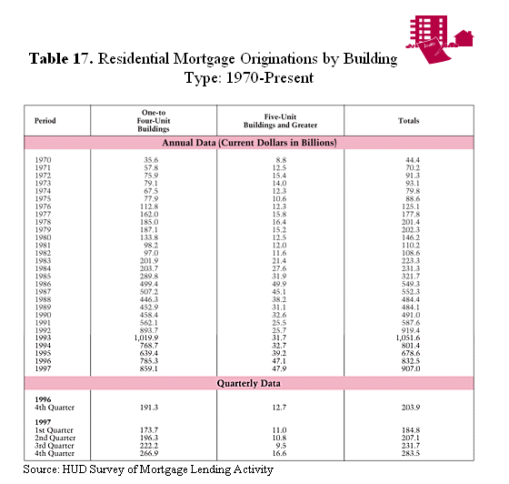

Source: http://www.huduser.org/periodicals/USHMC/fall98/histdat4.html#tbl4_16

Foreclosures
- Only current foreclosure activity counts for certain states (CA, FL, AZ, NV, IL, MI, OH, TX, GA, VA)
- Foreclosure activity, monthly on national level (graphical, not exact #’s) for Mar 2008 – Feb 2009
- Also includes breakout of national, monthly foreclosure activity (graphical, not exact #’s): pre-foreclosures, auction, and REO
Source: http://www.realtytrac.com/TrendCenter/default.aspx
Other

Consumer credit, household finance, mortgage debt outstanding.
Source: http://www.federalreserve.gov/econresdata/releases/statisticsdata.htm

Lots of historical data: http://www.huduser.org/periodicals/USHMC/fall98/toc.html
Table 1 -- New Privately Owned Housing Units Authorized: 1959-Present
Table 2 -- New Privately Owned Housing Units Started: 1959-Present
Table 3 -- New Privately Owned Housing Units Under Construction: 1969-Present
Table 4 -- New Privately Owned Housing Units Completed: 1968-Present
Table 5 -- Manufactured (Mobile) Home Shipments, Residential Placements, Average Prices, and Units for Sale: 1974-Present
Table 6 -- New Single-Family Home Sales: 1964-Present
Table 7 -- Existing Single-Family Home Sales: 1968-Present
Table 8A -- New Single-Family Home Prices: 1963-Present
Table 8B -- Existing Single-Family Home Prices: 1968-Present
Table 8C -- Repeat Sales House Price Index: 1980-Present
Table 9 -- Housing Affordability Index: 1970-Present
Table 10 -- Market Absorption of New Rental Units and Median Asking Rent: 1970-Present
Table 11 -- Builders' Views of Housing Market Activity: 1978-Present
Table 12 -- Mortgage Interest Rates, Average Commitment Rates, and Points: 1972-Present
Table 13 -- Mortgage Interest Rates, Points, Effective Rates, and Average Term to Maturity on Conventional Loans Closed: 1982-Present
Table 14 -- FHA, VA, and PMI 1-4 Family Mortgage Insurance Activity: 1968-Present
Table 15 -- FHA Unassisted Multifamily Mortgage Insurance Activity: 1980-Present
Table 16 -- Mortgage Originations, 1-4 Family Units by Loan Type: 1970-Present
Table 17 -- Residential Mortgage Originations by Building Type: 1970-Present
Table 18 -- Mortgage Originations, 1-4 Family Units by Lender Type: 1970-Present
Table 19 -- Net Acquisitions, 1-4 Family Units by Lender Type: 1970-Present
Table 20 -- Mortgage Delinquencies and Foreclosures Started: 1986-Present
Table 21 -- Expenditures for Existing Residential Properties: 1968-Present
Table 22 -- Value of New Construction Put in Place, Private Residential Buildings: 1974-Present
Table 23 -- Gross Domestic Product and Residential Fixed Investment: 1959-Present
Table 24 -- Net Change in Number of Households by Age of Householder: 1971-Present
Table 25 -- Net Change in Number of Households by Type of Household: 1971-Present
Table 26 -- Net Change in Number of Households by Race and Ethnicity of Householder: 1971-Present
Table 27 -- Total U.S. Housing Stock: 1970-Present
Table 28 -- Rental Vacancy Rates: 1979-Present
Table 29 -- Homeownership Rates by Age of Householder: 1982-Present
Table 30 -- Homeownership Rates by Region and Metropolitan Status: 1983-Present
Table 31 -- Homeownership Rates by Race and Ethnicity: 1983-Present
Table 32 -- Homeownership Rates by Household Type: 1983-Present

